

Assesment : Case Study
Topic: Legal document summarization

Name : Hemanth P
Reg No:192472285
Introduction
What is Legal Document Summarization?
Legal documents are often very lengthy and contain complex legal terminology. Examples include:
- Contracts
- Court Judgments
- Agreements
- Property Documents
- Company Policies
- Government Acts
Reading these documents manually takes a lot of time.
Generative AI and Large Language Models (LLMs) can automatically read the document, understand its meaning, and generate a concise summary while preserving important legal information.
This technology helps:
- Lawyers
- Judges
- Law Students
- Corporate Employees
- Government Officials
to quickly understand lengthy legal documents.
Problem Statement
Legal documents generally contain:
- Hundreds of pages
- Complex legal language
- Repeated clauses
- Long paragraphs
- Difficult terminology
Manual summarization has several disadvantages:
- Time consuming
- Human errors
- Missing important clauses
- High cost
- Low productivity
Therefore, an AI-based summarization system is required.

Analysis of the Problem
The AI system must perform the following tasks:
Step 1
Receive the legal document.
Input formats:
- PDF
- DOCX
- TXT
↓
Step 2
Extract text.
↓
Step 3
Clean the text
Remove:
- unwanted spaces
- headers
- footers
- page numbers
↓
Step 4
Understand legal language
The model identifies:
- parties involved
- obligations
- penalties
- important clauses
- dates
- conditions
↓
Step 5
Generate summary
↓
Step 6
Display summarized document
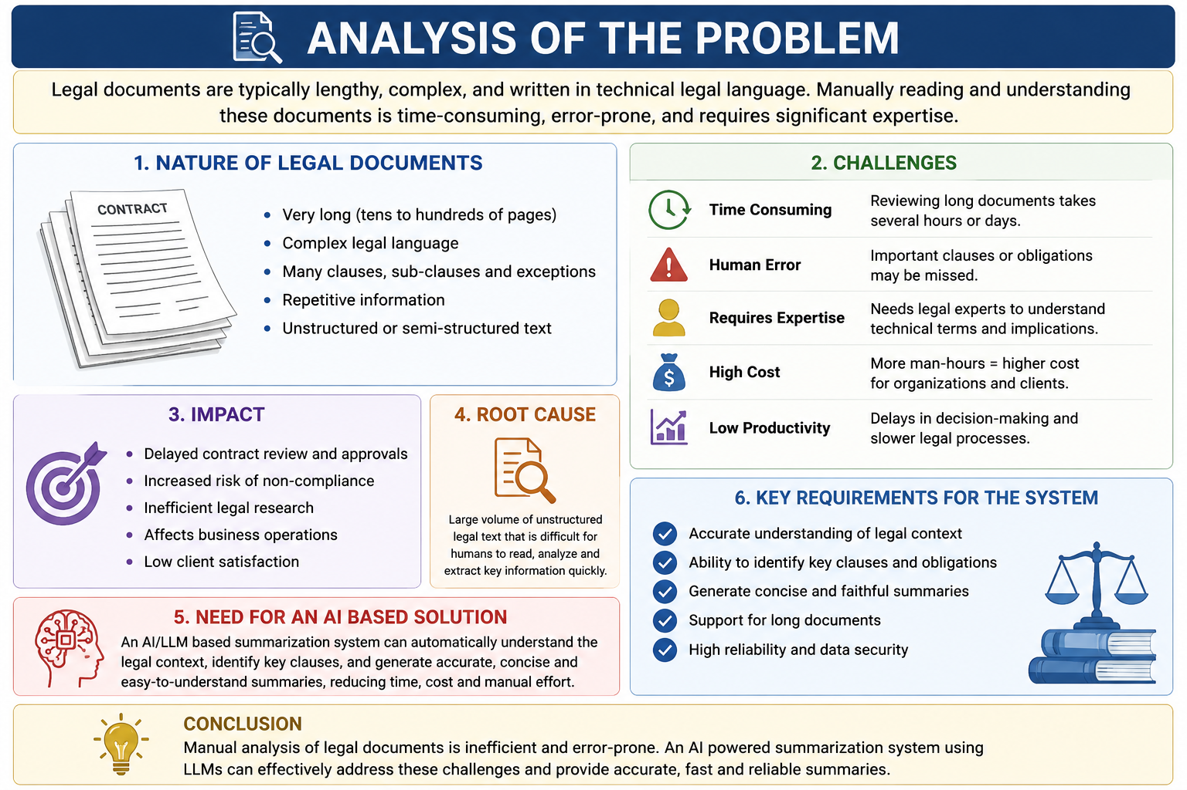

Proposed Solution
The proposed solution uses Large Language Models (LLMs) such as GPT to summarize legal documents.
The AI system performs:
- Document upload
- Text extraction
- NLP preprocessing
- Understanding legal context
- Generating summary
- Reviewing important clauses

Justification
Generative AI is suitable because it understands natural language instead of simply extracting keywords.
Advantages:
- Better understanding
- Context-aware
- Faster processing
- High-quality summaries
- Human-like language generation
- Reduced workload
- Improved productivity

Suitable Model Selection
A. GPT (Recommended)
Why GPT?
GPT is a Generative AI model capable of understanding long legal documents and generating human-like summaries.
Advantages
- Excellent language understanding
- Context-aware
- High accuracy
- Fluent summaries
- Supports long documents
Example
Input:
25-page contract
Output:
2-page easy-to-read summary

B. BERT
Purpose:
Understanding text.
BERT is mainly used for:
- Text classification
- Legal clause identification
- Named Entity Recognition (NER)
Advantages
- Bidirectional understanding
- High contextual accuracy
Limitation
Cannot naturally generate summaries like GPT.

C. RLHF (Reinforcement Learning from Human Feedback)
Purpose:
Improve summary quality.
Experts review AI-generated summaries.
Their feedback improves the model.
Benefits
- More accurate
- Safer
- Better legal interpretation
- Human-aligned responses

D. LoRA (Low Rank Adaptation)
Purpose
Fine-tuning GPT using small datasets.
Advantages
- Low memory usage
- Faster training
- Low computational cost
Useful when:
Training on legal datasets.

E. PEFT (Parameter Efficient Fine Tuning)
Purpose
Efficiently fine-tune large models.
Advantages
- Lower GPU requirement
- Faster deployment
- Less storage
Suitable for:
Legal domain adaptation.

Why Choose GPT Over Other Models?
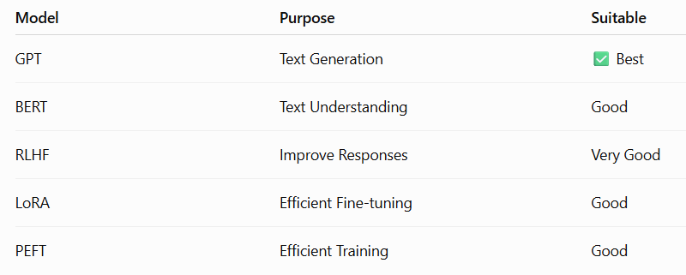Final Selection
GPT + RLHF + LoRA + PEFT
Reason:
Provides accurate, efficient, and high-quality legal summaries with lower training cost.
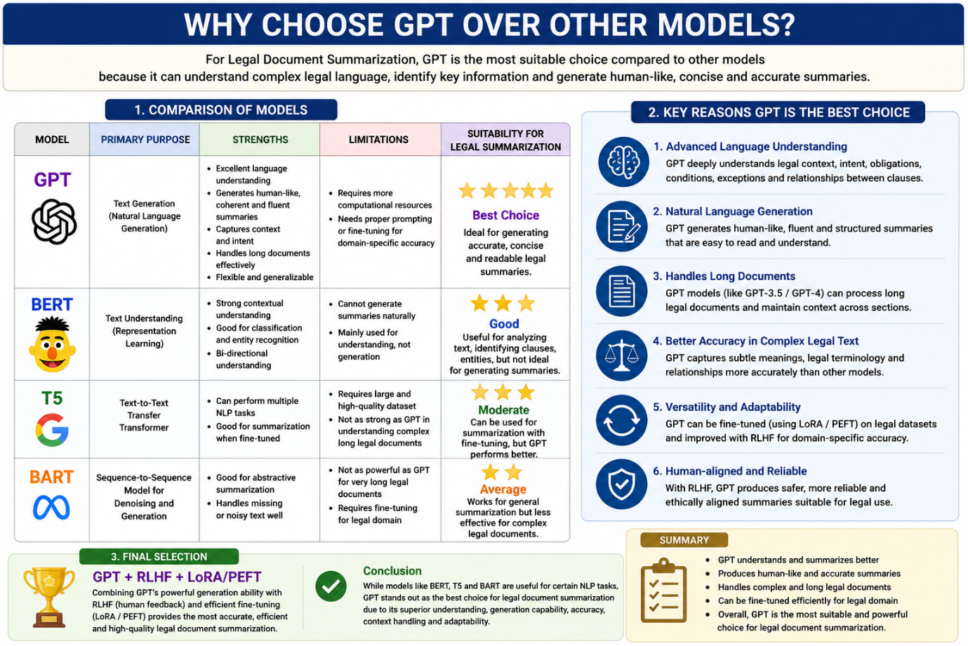

Implementation Approach
Step 1
Upload legal document
↓
Step 2
Convert PDF to text
↓
Step 3
Text preprocessing
- Remove symbols
- Remove headers
- Remove duplicates
↓
Step 4
Tokenization
↓
Step 5
Feed text into GPT
↓
Step 6
Generate summary
↓
Step 7
Human verification (optional)
↓
Step 8
Display final summary

FLOWCHART

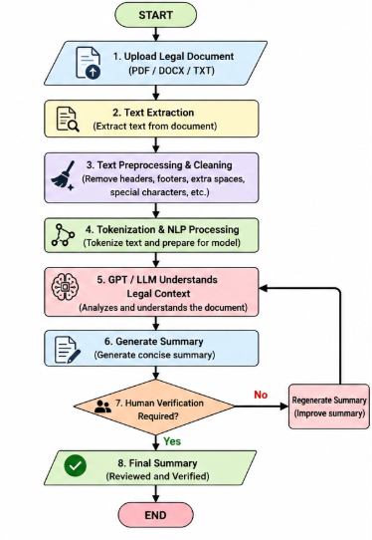

BLOCK DIAGRAM

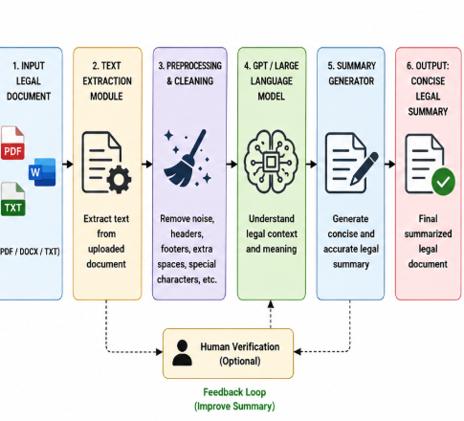

INPUT
Employment Agreement

Employee Name: John

Company Name: ABC Ltd.

The employee shall maintain confidentiality.

The employment begins on January 1, 2026.

Salary:
₹60,000 per month.

Notice Period:
30 Days.

OUTPUT
This employment agreement is between John and ABC Ltd.

The employee will receive a monthly salary of ₹60,000.

Employment starts on January 1, 2026.

The employee must maintain confidentiality.

A 30-day notice period is required before resignation.

Expected Outcome
The system should:
- Reduce reading time
- Produce concise summaries
- Preserve important legal information
- Improve productivity
- Reduce manual effort
- Increase efficiency for legal professionals

Advantages
- Saves time
- High accuracy
- Easy to understand
- Faster document review
- Cost-effective
- Supports large documents
- Reduces workload
- Improves legal research

Limitations
- May miss subtle legal nuances.
- Performance depends on the quality of the input document.
- Very long documents may need to be split into sections.
- AI-generated summaries should be reviewed by legal experts before making important legal decisions.
- Fine-tuning and deployment can require significant computing resources.

Future Enhancements
- Multi-language legal summarization.
- Voice-based legal document explanation.
- Integration with court databases.
- Clause risk detection.
- AI-powered legal question answering.
- Automatic contract comparison.
- Real-time legal compliance checking.

Conclusion
Generative AI and Large Language Models (LLMs) provide an effective solution for summarizing legal documents. Among the available models, GPT is the best choice because it can generate coherent, context-aware summaries, while BERT enhances text understanding and RLHF, LoRA, and PEFT improve quality and enable efficient domain adaptation. The proposed system reduces the time needed to review lengthy legal documents, improves productivity, and helps legal professionals quickly identify key information. However, AI-generated summaries should always be reviewed by legal experts when accuracy is critical.

